-- 1. Explain the difference between the UNION ALL and UNION operators. In what cases are the two equivalent? When they are equivalent, which one should you use?

The UNION ALL operator unifies the two input query result sets and doesn’t remove duplicates from the result. The UNION operator (implied DISTINCT) also unifies the two input query result sets, but it does remove duplicates from the result. They have an

equivalent meaning when the result can’t have duplicates, such as when you’re unifying disjoint sets (for example, sales 2015 with sales 2016). When they do have the same meaning, you need to use UNION ALL by default. That’s to avoid paying unnecessary performance penalties for the work involved in removing duplicates when they don’t exist.

-- 2. Write a query that generates a virtual auxiliary table of 10 numbers in the range 1 through 10 without using a looping construct. You do not need to guarantee any order of the rows in the output of your solution:

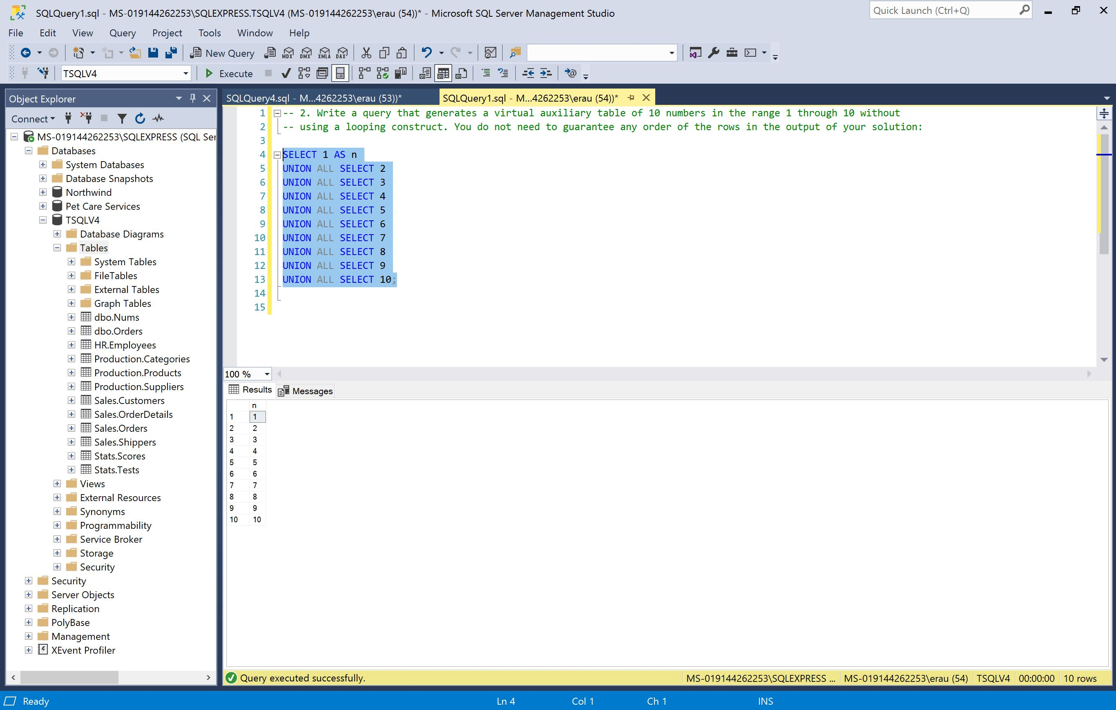

-- 3. Write a query that returns customer and employee pairs that had order activity in January 2016 but not in February 2016:

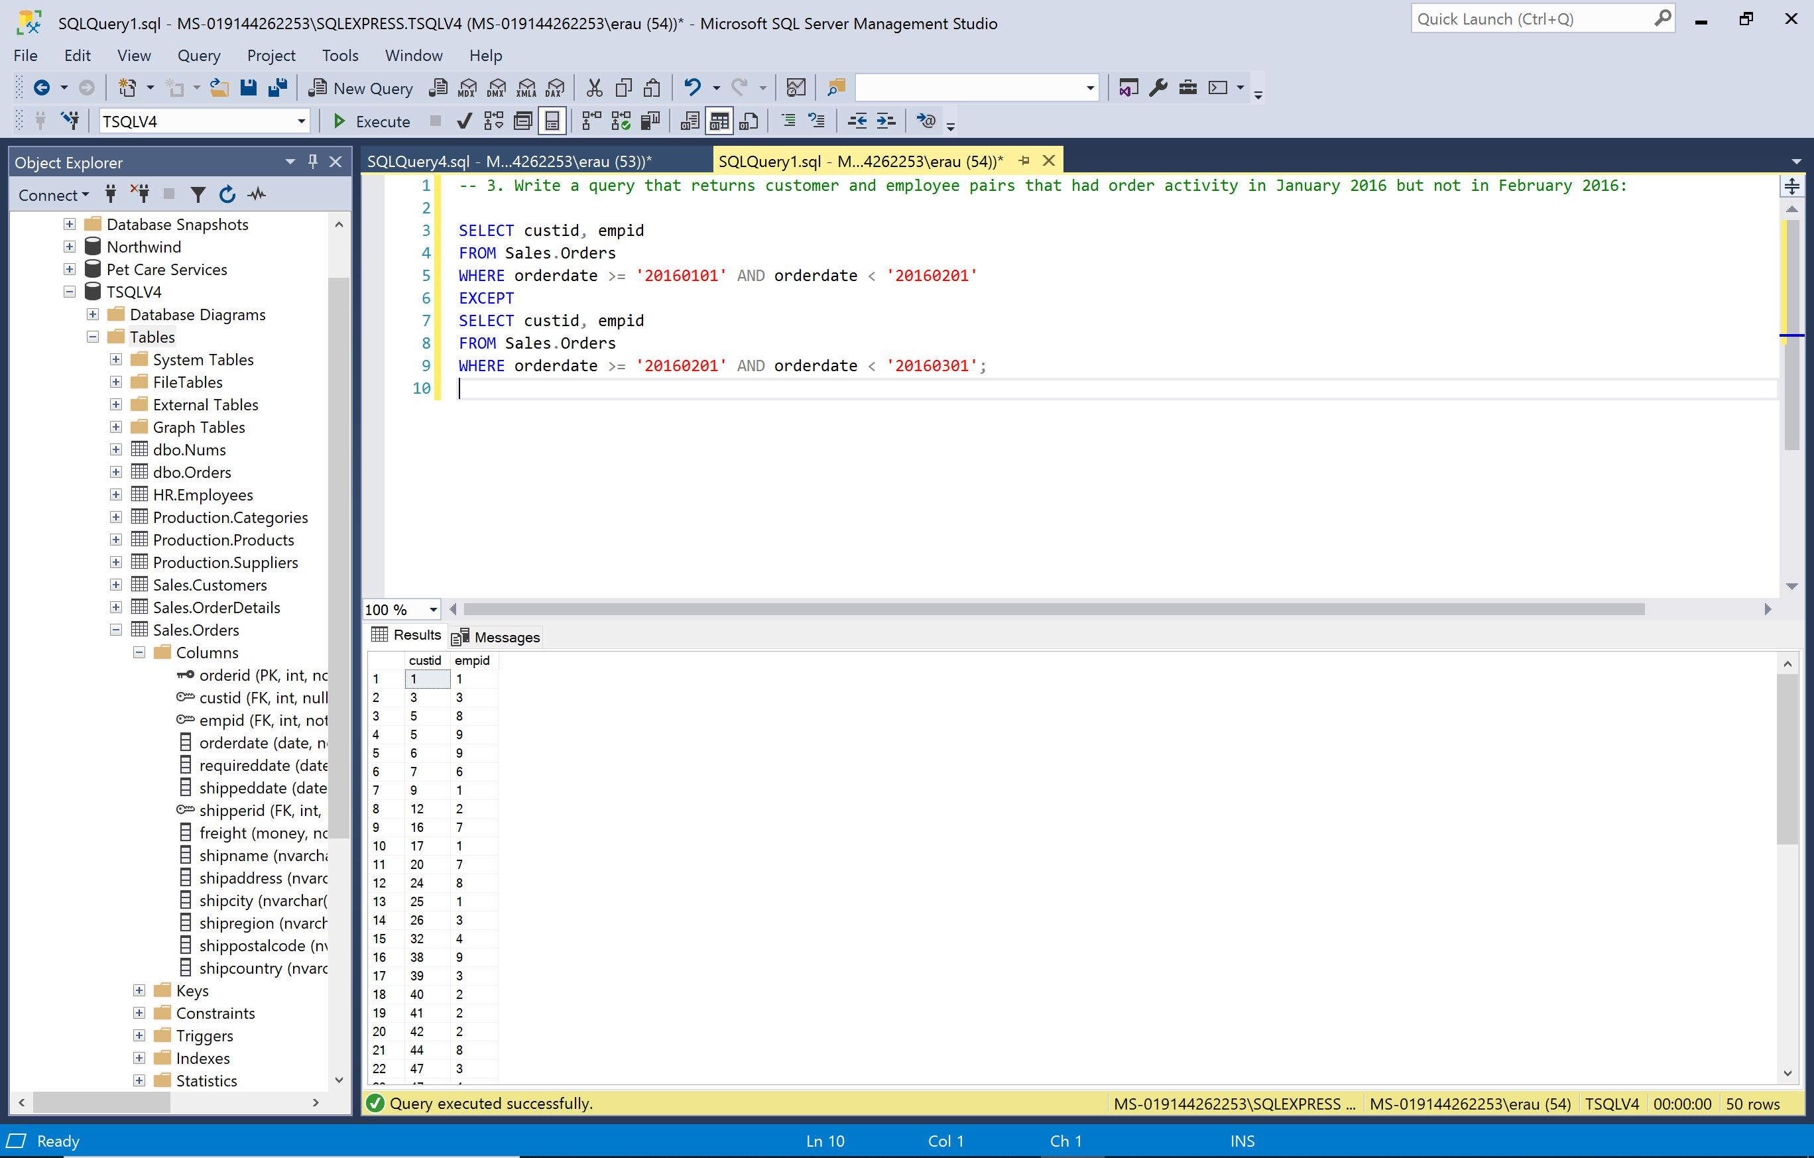

-- 4. Write a query that returns customer and employee pairs that had order activity in both January 2016 and February 2016:

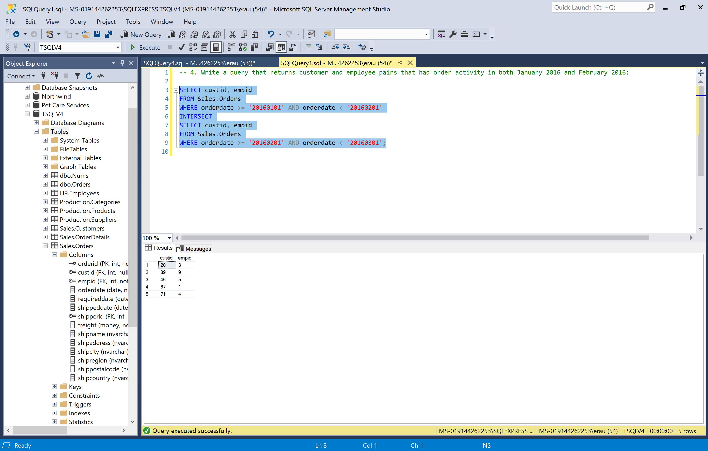

-- 5. Write a query that returns customer and employee pairs that had order activity in both January 2016 and February 2016 but not in 2015:

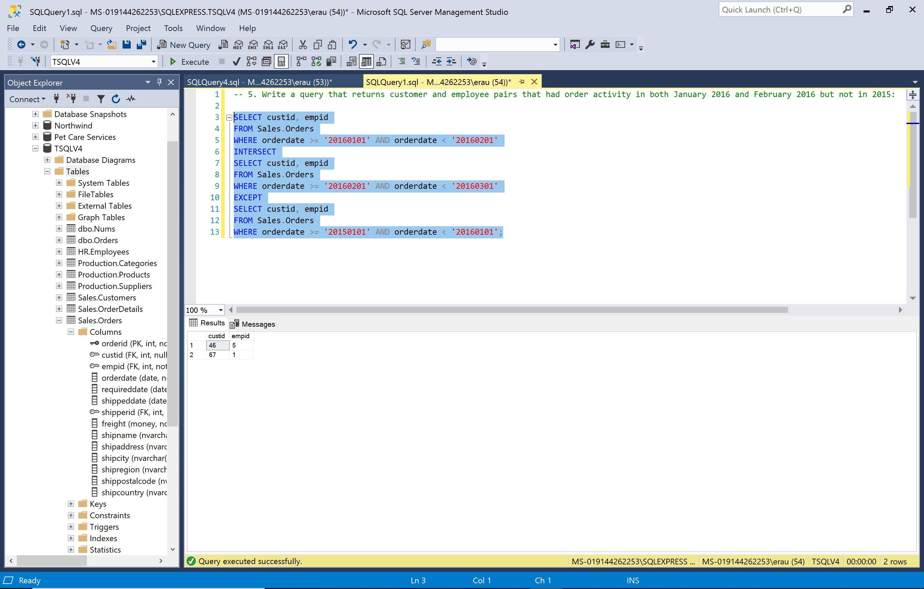

-- 6. Add logic to the query so that it guarantees that the rows from Employees are returned in the output before the rows from Suppliers. Also, within each segment, the rows should be sorted by country, region, and city:

